**Mini Project Report - 06**

Master of Computer Application – General

Semester – III

**Sub: Web Technologies**

**Topic: Multimedia Page**   
By  
**Name:** SANDRA B  
**Reg no.:** 24110222500001

**Faculty Name:** VEERA RAGHAV K

**Faculty Signature: _______________**

**Department of Computer Application  
Alliance University  
Chandapura - Anekal Main Road, Anekal  
Bengaluru - 562 106**

**August 2025**

|  |  |  |
| --- | --- | --- |
| **Sno.** | **INDEX** | **Page No.** |
| 1. | Introduction | 2 |
| 2. | Objective | 2 |
| 3. | Tools and Technologies Used | 3 |
| 4. | Description of Code | 3 |
| 5. | Working of the Project | 4 |
| 6. | Features | 5 |
| 7. | Output | 5 |
| 8. | Advantages | 8 |
| 9. | Future Scope | 8 |
| 10. | Conclusion | 9 |

**Report on Multimedia Web Project**

**1. Introduction**

The rapid growth of technology has transformed how educational institutions interact with students and the community. Websites act as the **digital face** of universities, showcasing their programs, events, and services while also providing students with online platforms for engagement.

This project is a **mini multimedia-based website** created using **HTML, CSS, and JavaScript** that simulates the login process and demonstrates features of a university web portal.

The website has **two main pages**:

* **Login Page:** Allows users to log in with details like User ID, Name, Email, and Password. It also includes a Feedback section.
* **Multimedia Home Page:** Displays university details, rankings, images, videos, audio tracks, and a well-structured footer with quick links.

This project not only helps in understanding **frontend web technologies** but also demonstrates the integration of multimedia content such as **images, audio, and video**.

**2. Objectives**

The main objectives of this project are:

1. To design a **simple and user-friendly login page** for users.
2. To develop a **multimedia-rich webpage** representing a university demo site.
3. To demonstrate the **use of HTML tags** for structure and **CSS for styling**.
4. To integrate multimedia elements like **images, audio, and video**.
5. To implement **navigation links and buttons** for smooth user interaction.
6. To showcase **best practices** in web design such as responsiveness, structured layout, and interactivity.
7. To provide a **practical understanding of real-world university websites**.

**3. Tools and Technologies Used**

The project is developed using **basic web technologies** without advanced frameworks.

* **HTML (HyperText Markup Language):** For structuring the webpage content.
* **CSS (Cascading Style Sheets):** For styling, layout, and visual design.
* **JavaScript:** For basic interactivity (alert message on login).
* **Multimedia Files:** Images (.jpg, .png, .webp), Audio (.mp3), and Video (embedded from YouTube).
* **Browser:** Google Chrome / Microsoft Edge for testing.
* **Editor:** VS Code (Visual Studio Code).

**4. Description of the Code**

The project is divided into **two main parts**:

**A) Login Page (First Page)**

* Background image (Alliance University campus.jpg).
* University Logo (au.png).
* A **form** with fields for:
  + User ID
  + Name
  + Email
  + Password
  + Feedback (textarea)
* A **Sign In button** with a JavaScript alert "Login Successfully!".
* On successful login, it redirects the user to the **second page**.

**B) Alliance University Demo Page (Second Page)**

* **Utility bar** at the top (links to Alumni, Library, Careers, Login).
* **Navigation bar** with logo and links (About, Faculty, Programs, Admissions).
* **Body Section:**
  + University Rankings displayed with **medal-style boxes**.
  + Buttons: Campus Tour, Apply Now, Contact Us.
* **About Section:** A descriptive paragraph about the university.
* **Events Section:**
  + Images of events.
  + Embedded YouTube videos.
* **Singing Competitions Section:**
  + Multiple audio files with play controls.
* **Footer Section:**
  + Quick links for About, Schools, Programmes, Admissions, Important Links.
  + Contact information and helpline numbers.

**5. Working of the Project**

1. The user opens the **Login Page**.
2. The user enters details in the form.
3. When the user clicks **Sign In**, a **JavaScript alert** appears saying *"Login Successfully!"*.
4. The page then redirects to the **University Demo Page**.
5. On the Demo Page, users can:
   * View university rankings.
   * Explore the About Us section.
   * Browse events with images and videos.
   * Play audio files from singing competitions.
   * Use the footer links for quick navigation.

**6. Features**

* Clean and simple **login form** with validation fields.
* Use of **background images** for better visual appeal.
* Interactive **alert message** on login.
* Multimedia Integration:

* Images (img tags).

* Audio (audio tags).

* Video (iframe embedding YouTube).  
   * Responsive **flexbox layout** for ranks and footer.  
   * **Navigation bar** with external links.  
   * Well-structured **footer with multiple columns**.  
   * Professional **university theme design**.

**7. Output**

**Login Page Output:**

* Background university campus image.
* Centered form with input fields.
* Sign In button triggers a popup alert.

**Alliance University Demo Page Output:**

* Utility bar + navigation bar.
* University rankings displayed in boxes.
* Event images and embedded videos.
* Audio playlist for competitions.
* Footer with multiple link sections.

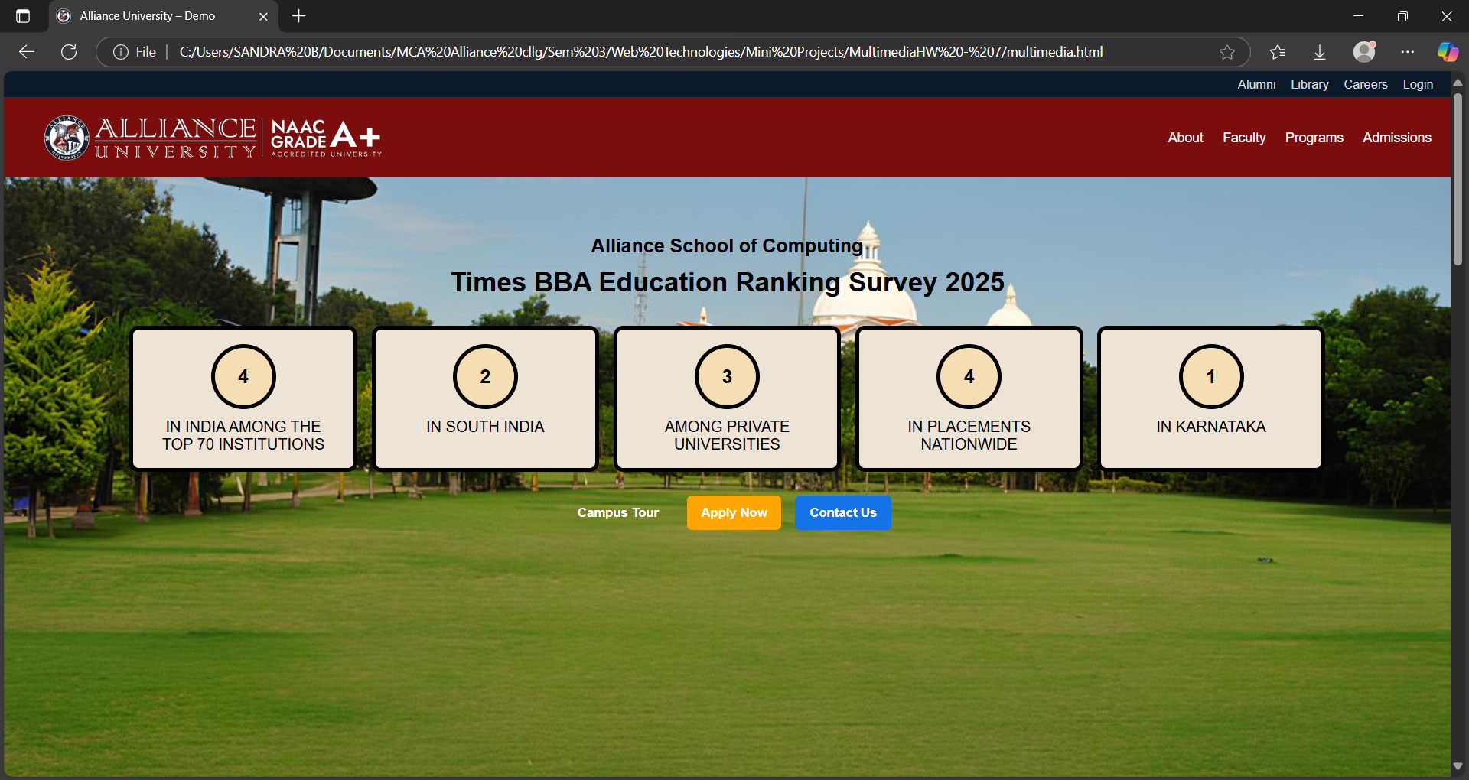

**8. Advantages**

1. **Easy to Use:** Simple UI for login and navigation.
2. **Attractive Design:** Use of multimedia makes the site engaging.
3. **Educational Value:** Demonstrates practical HTML, CSS, and JavaScript usage.
4. **Scalability:** Can be extended to a complete student portal.
5. **Cross-browser Compatibility:** Works on all modern browsers.
6. **Reusability:** The template can be adapted for other institutions.

**9. Future Scope**

🔹 The project can be expanded into a **fully functional student portal** by adding:

* **Database Connectivity (MySQL, MongoDB):** Store login data securely.
* **User Authentication:** Validate login using PHP/Node.js backend.
* **Responsive Design:** Improve layout for mobile devices.
* **Dynamic Events Section:** Use JavaScript or APIs to load events dynamically.
* **Online Registration:** Allow students to apply or register online.
* **Admin Panel:** Manage users, events, and announcements.

**10. Conclusion**

This project demonstrates how **basic web technologies** can be used to design a **functional and multimedia-rich website**.

The login page introduces **form handling and user interactivity**, while the university demo page showcases how multimedia can be integrated to enhance the visual experience.

Through this project, the concepts of **HTML structure, CSS styling, JavaScript interactivity, and multimedia embedding** have been successfully applied.

It lays a strong foundation for building more **advanced dynamic websites** with database support and real-time functionality.